OBSERVATION:
1.Use Employee database
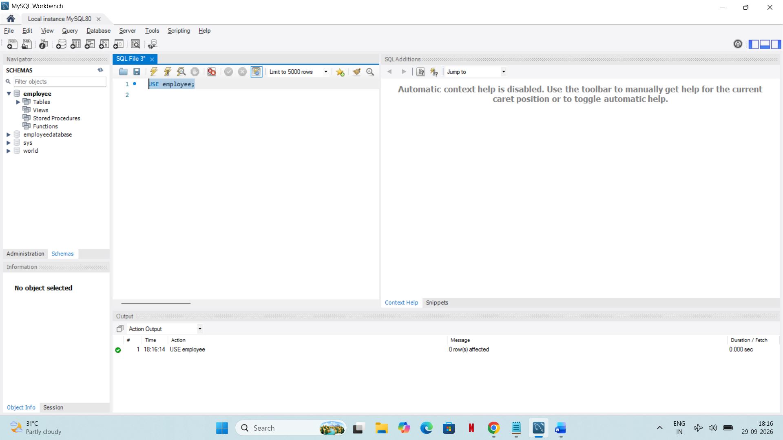
2.Show Table
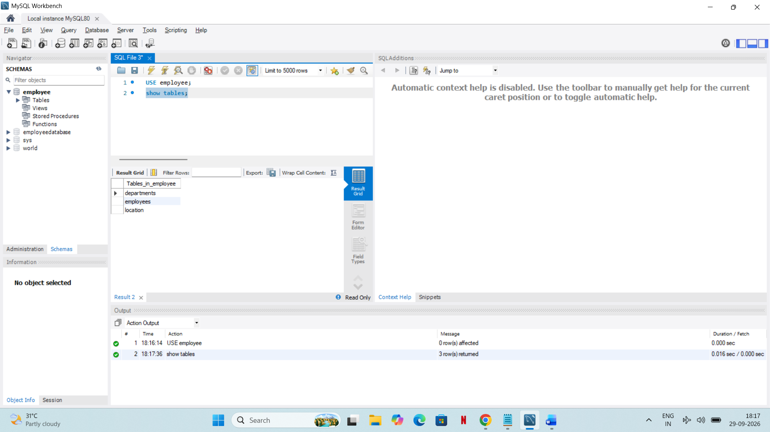
3. insert the data into the department , location and employee details
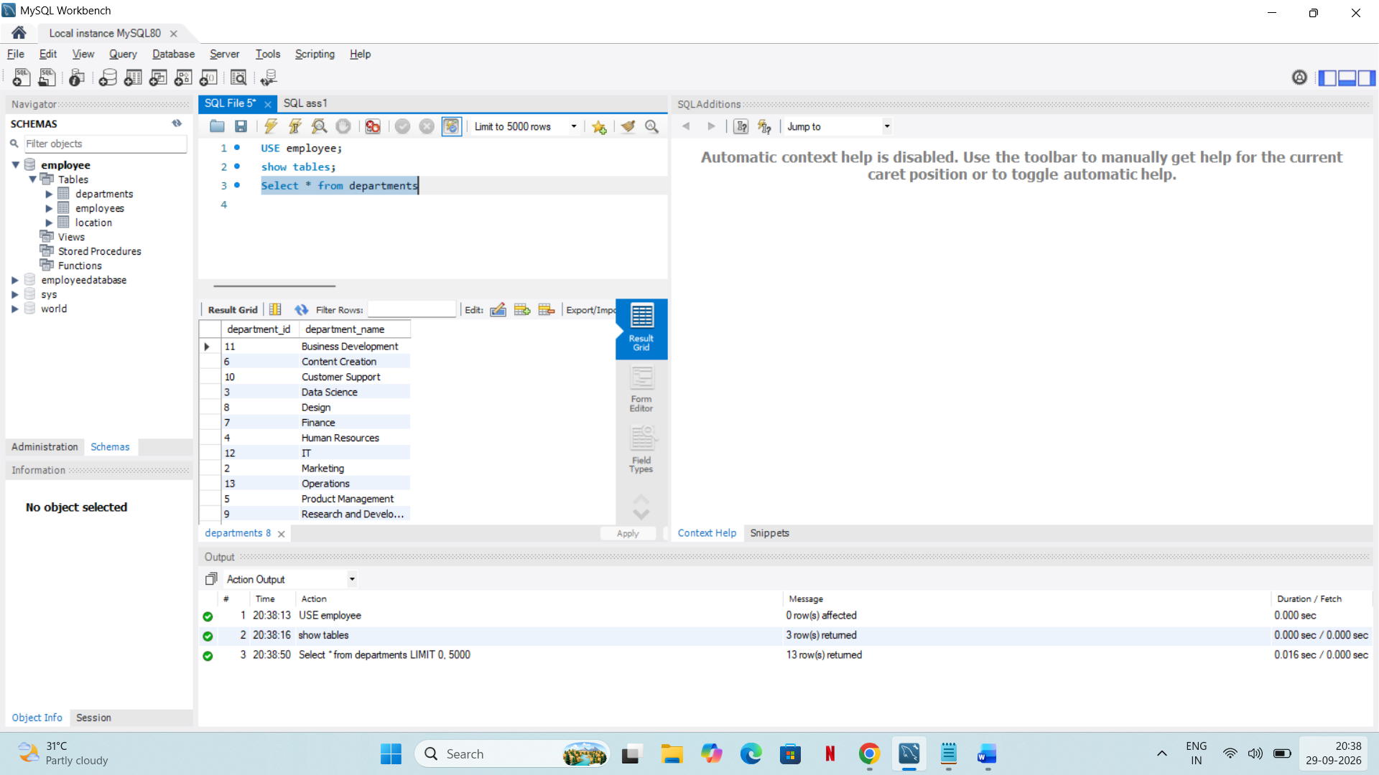
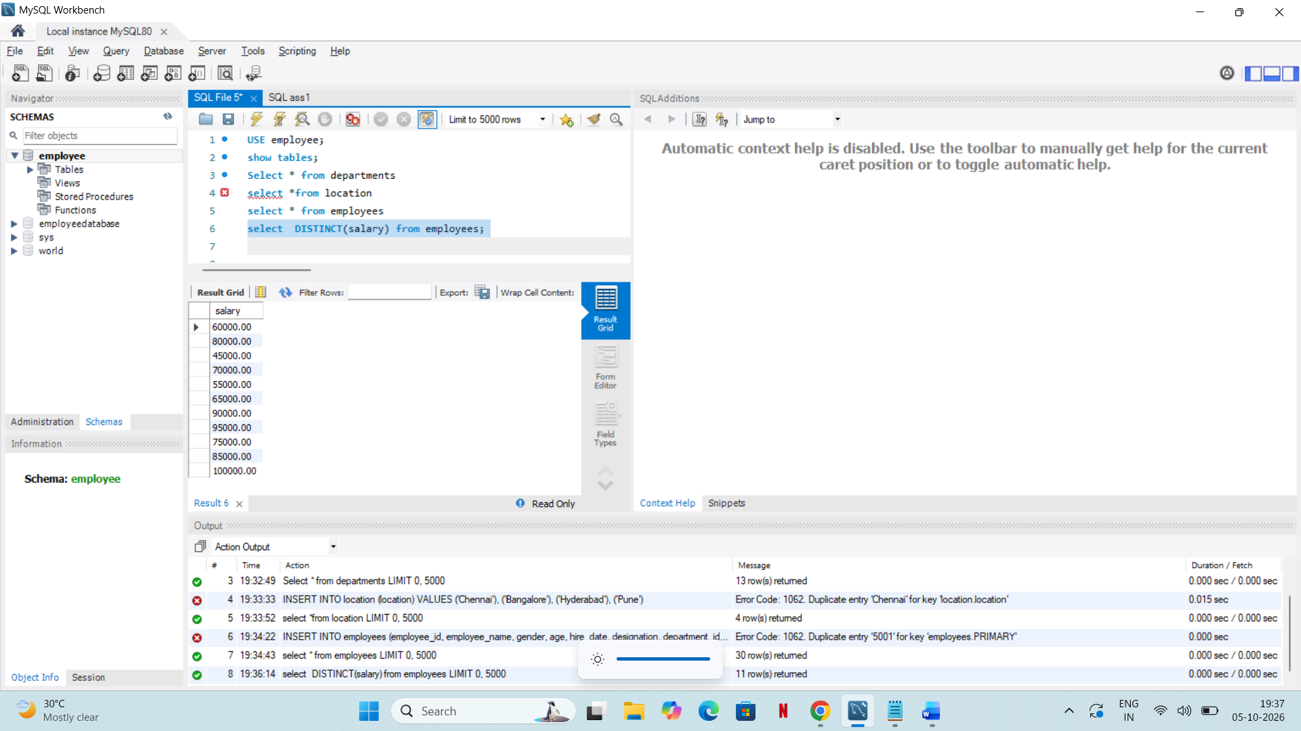
4.A query to retrieve distinct salaries from the Employees table

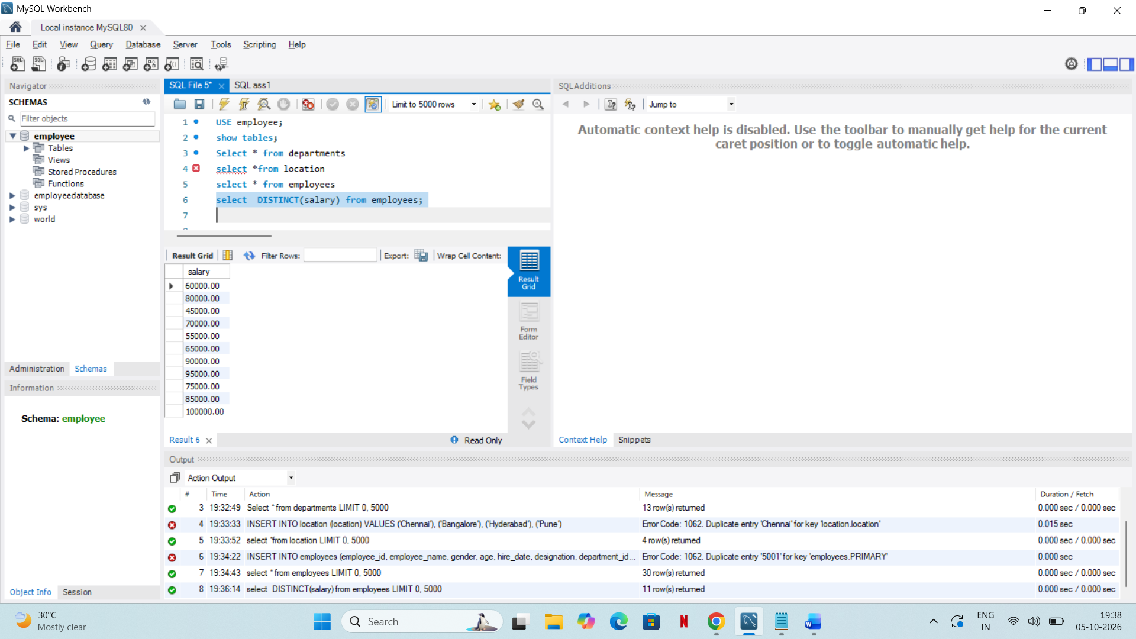
5. Provide aliases for the "age" and "salary" columns as "Employee_Age" and "Employee_Salary", respectively.
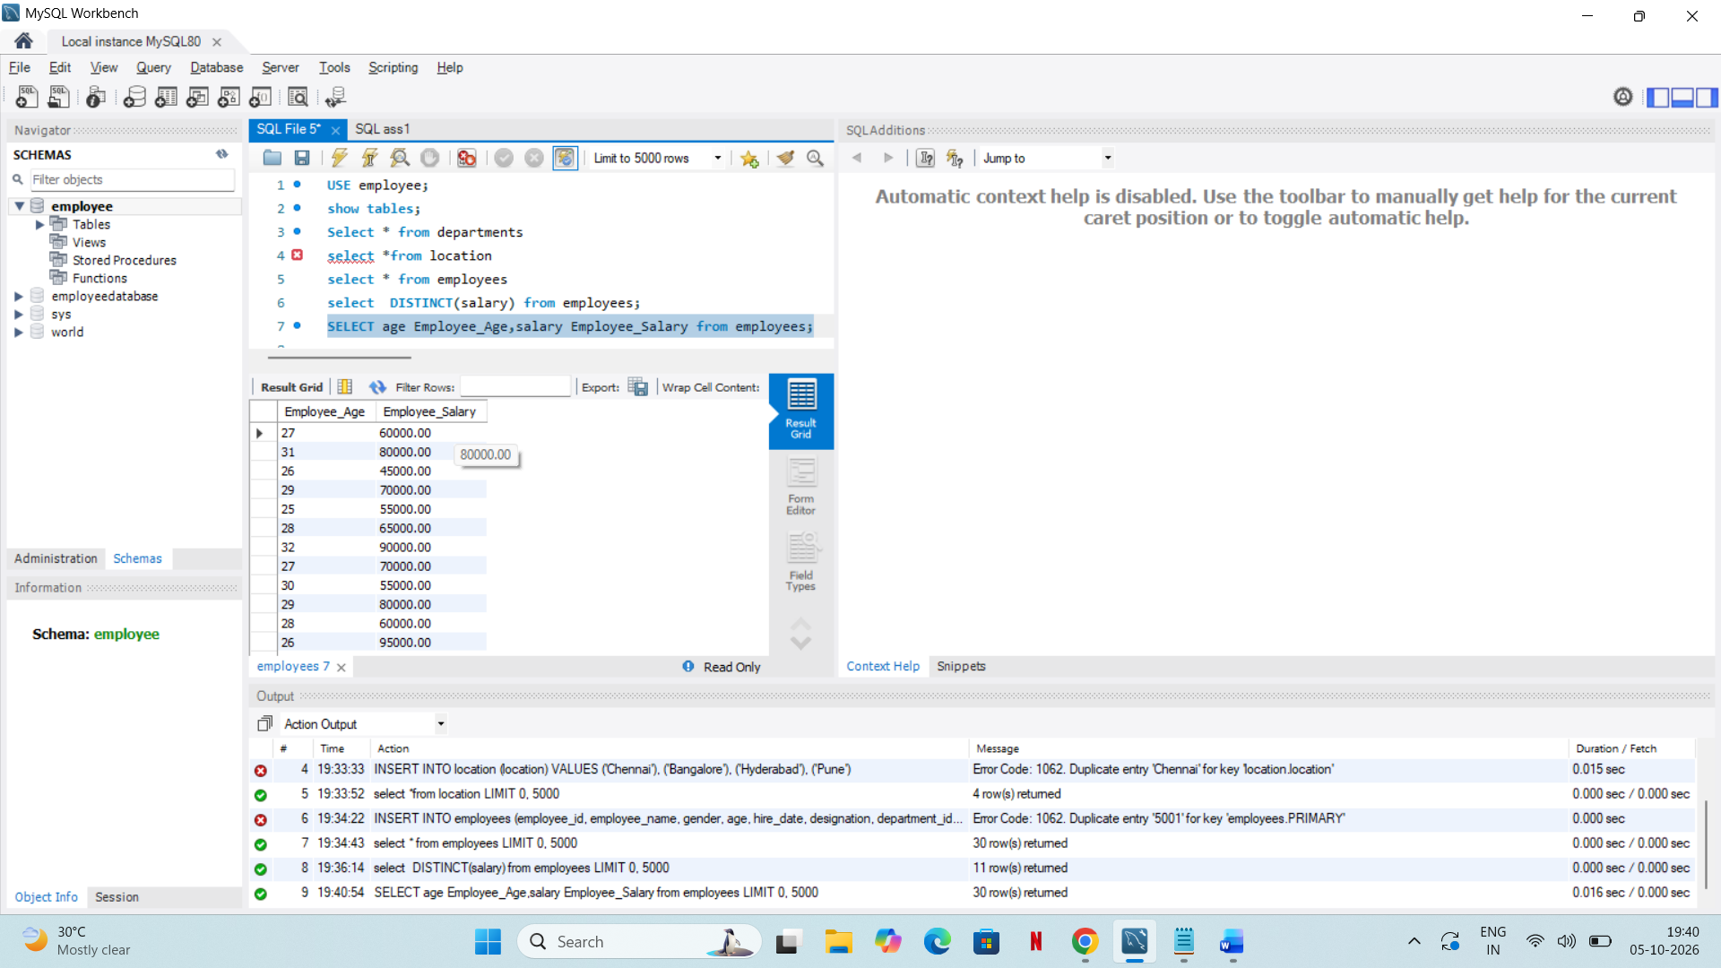

Where Clause & Operators: ⦿ Retrieve employees with a salary greater than ₹50000 and hired before 2016-01-01.
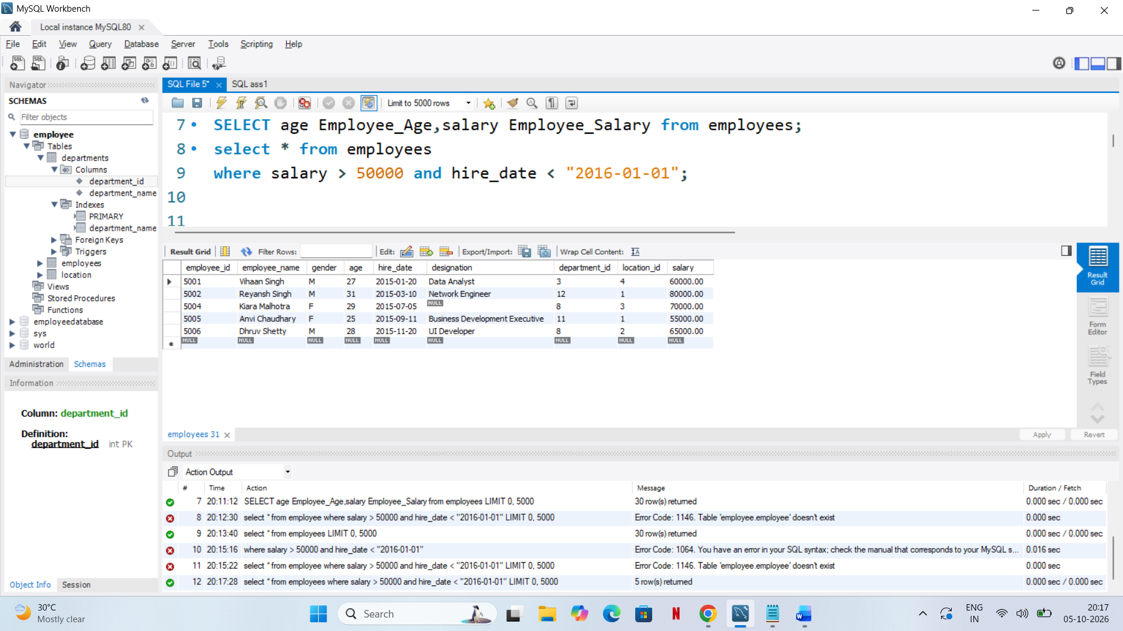
Find the employee whose designation is missing and fill it with "Data Scientist".
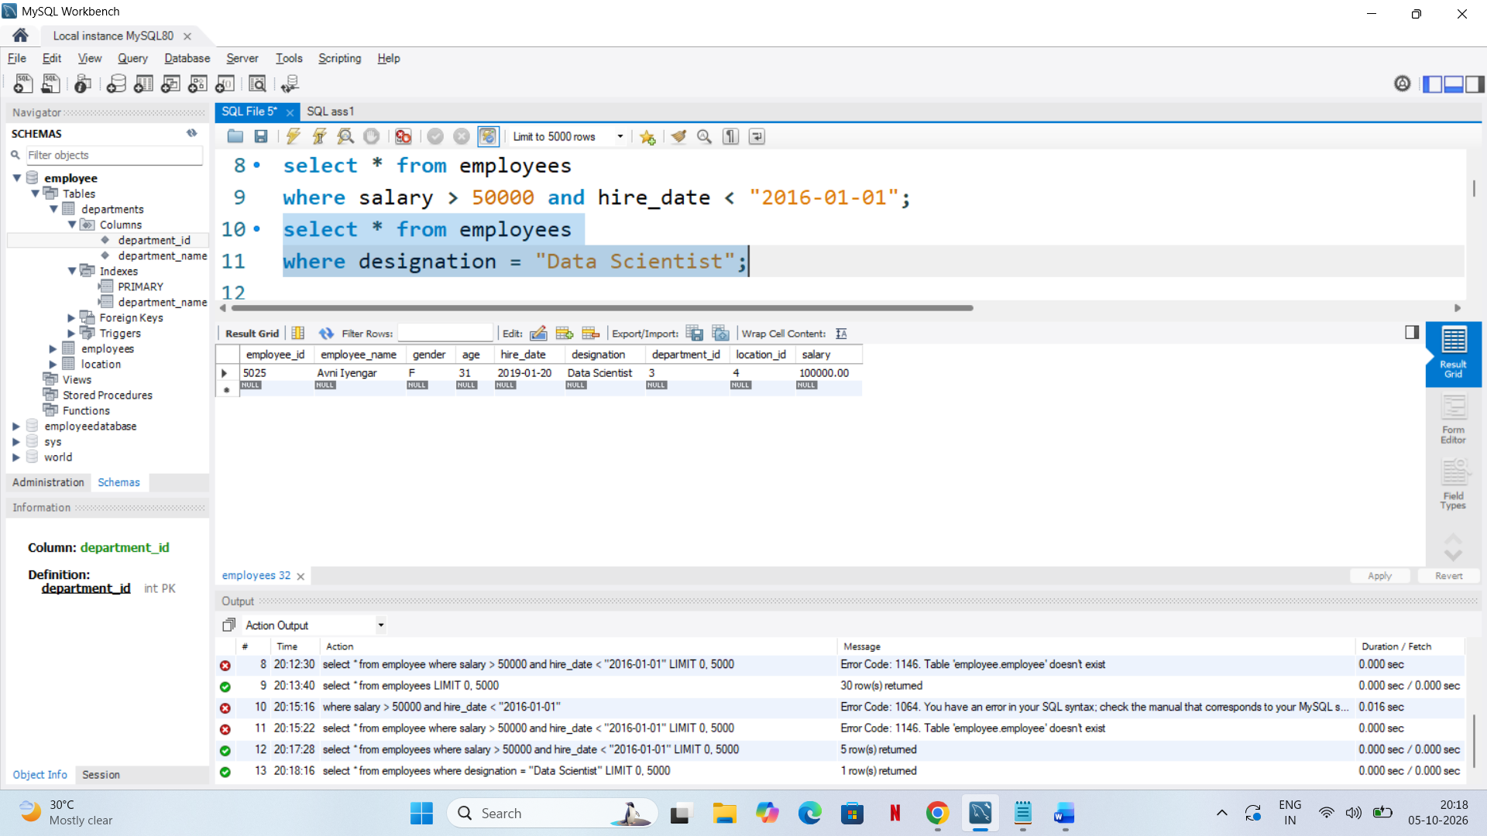
ORDER BY: Find employees sorted by department ID in ascending order and salary in descending order.
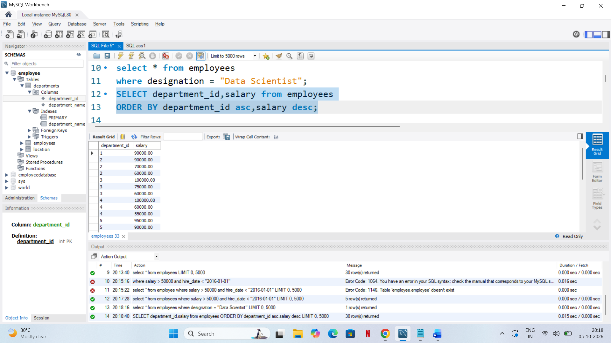
Calculate the sum of all salaries in the Finance department.
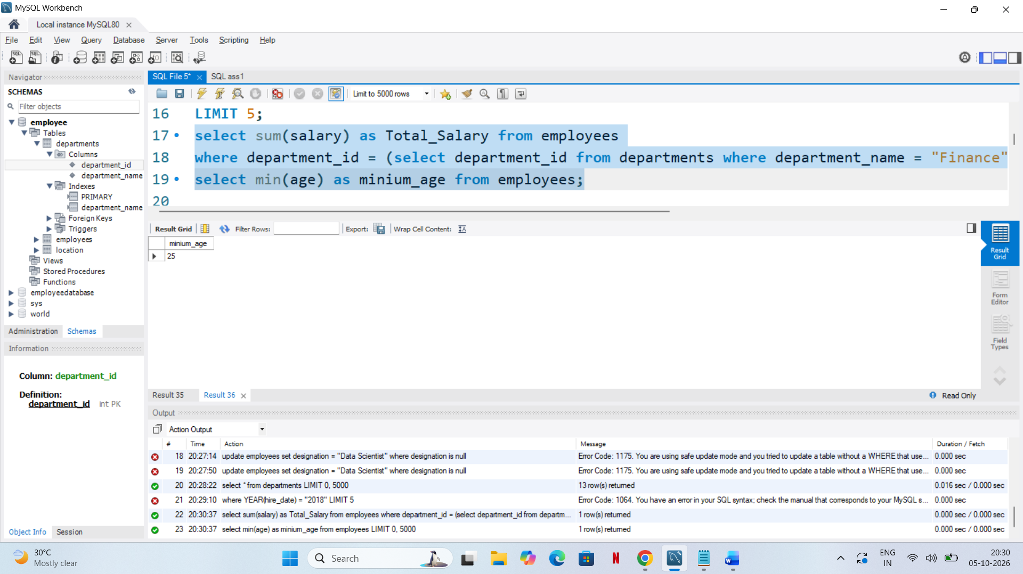

List the maximum salary for each location.
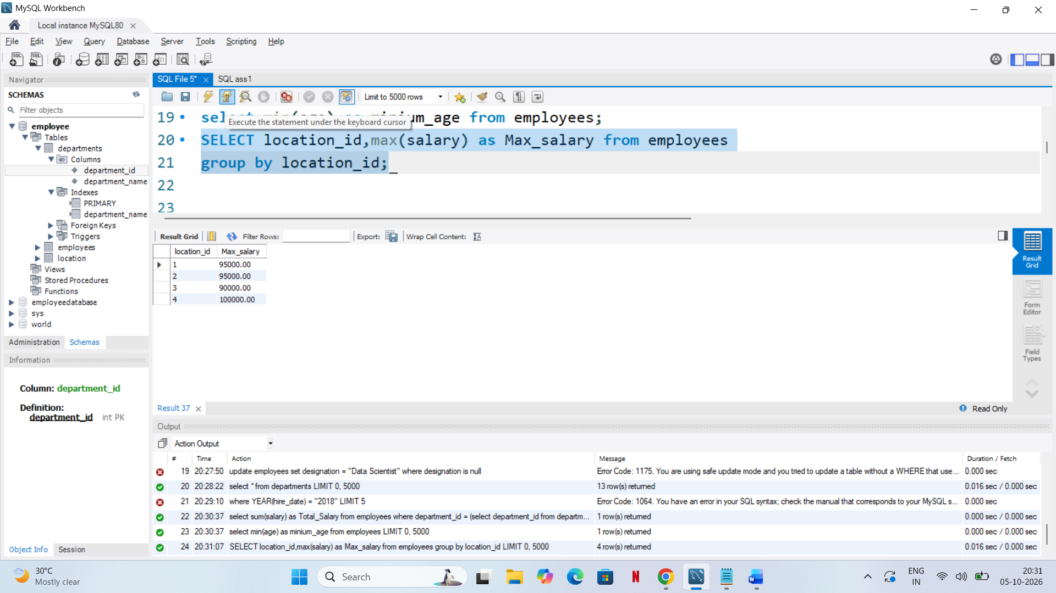
Calculate the average salary for each designation containing the word 'Analyst'.
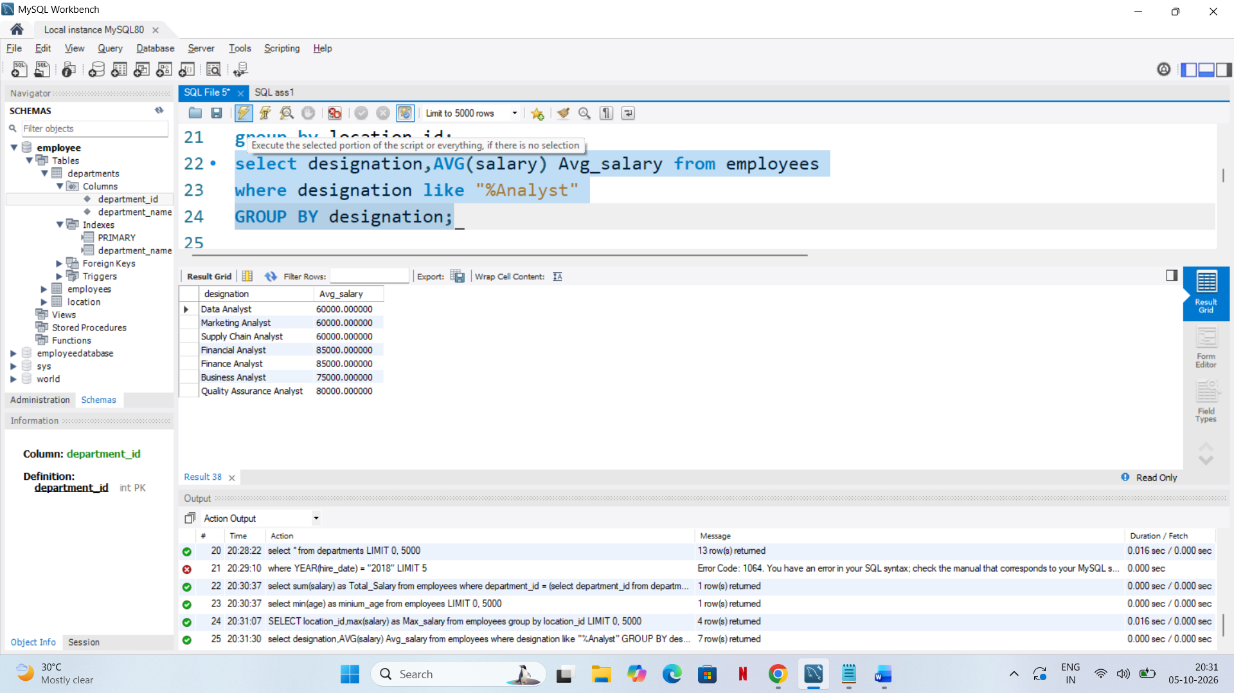
Find departments with less than 3 employees.
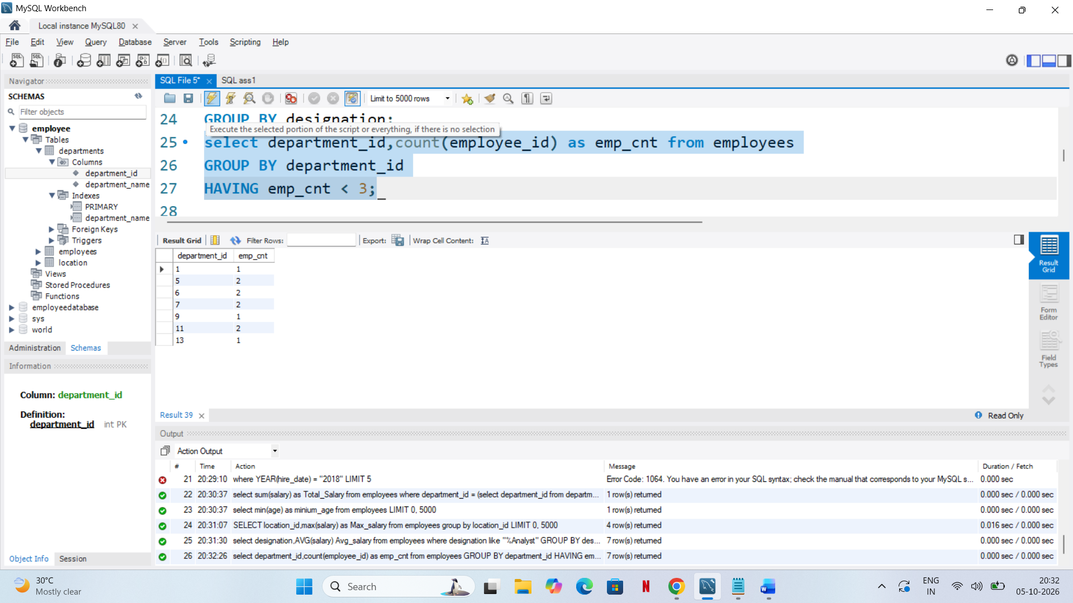
.Find locations with female employees whose average age is below 30.
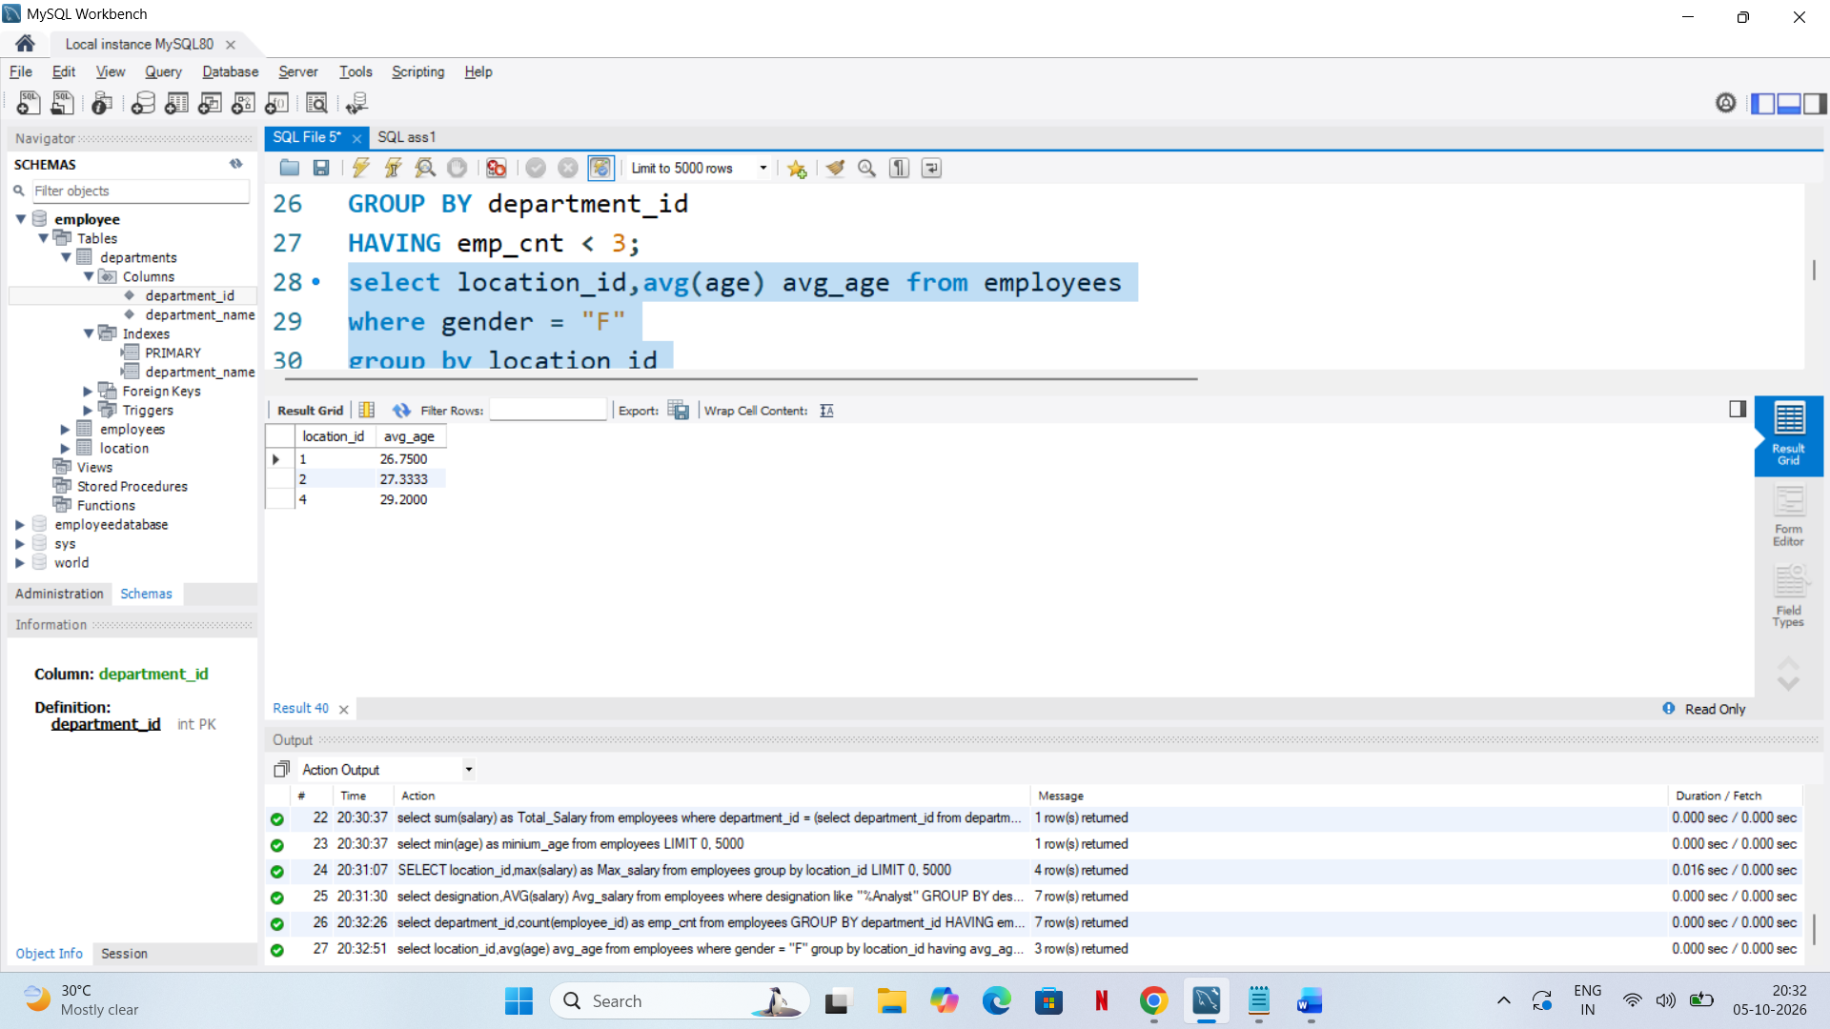
List employee names, their designations, and department names where employees are assigned to a department.
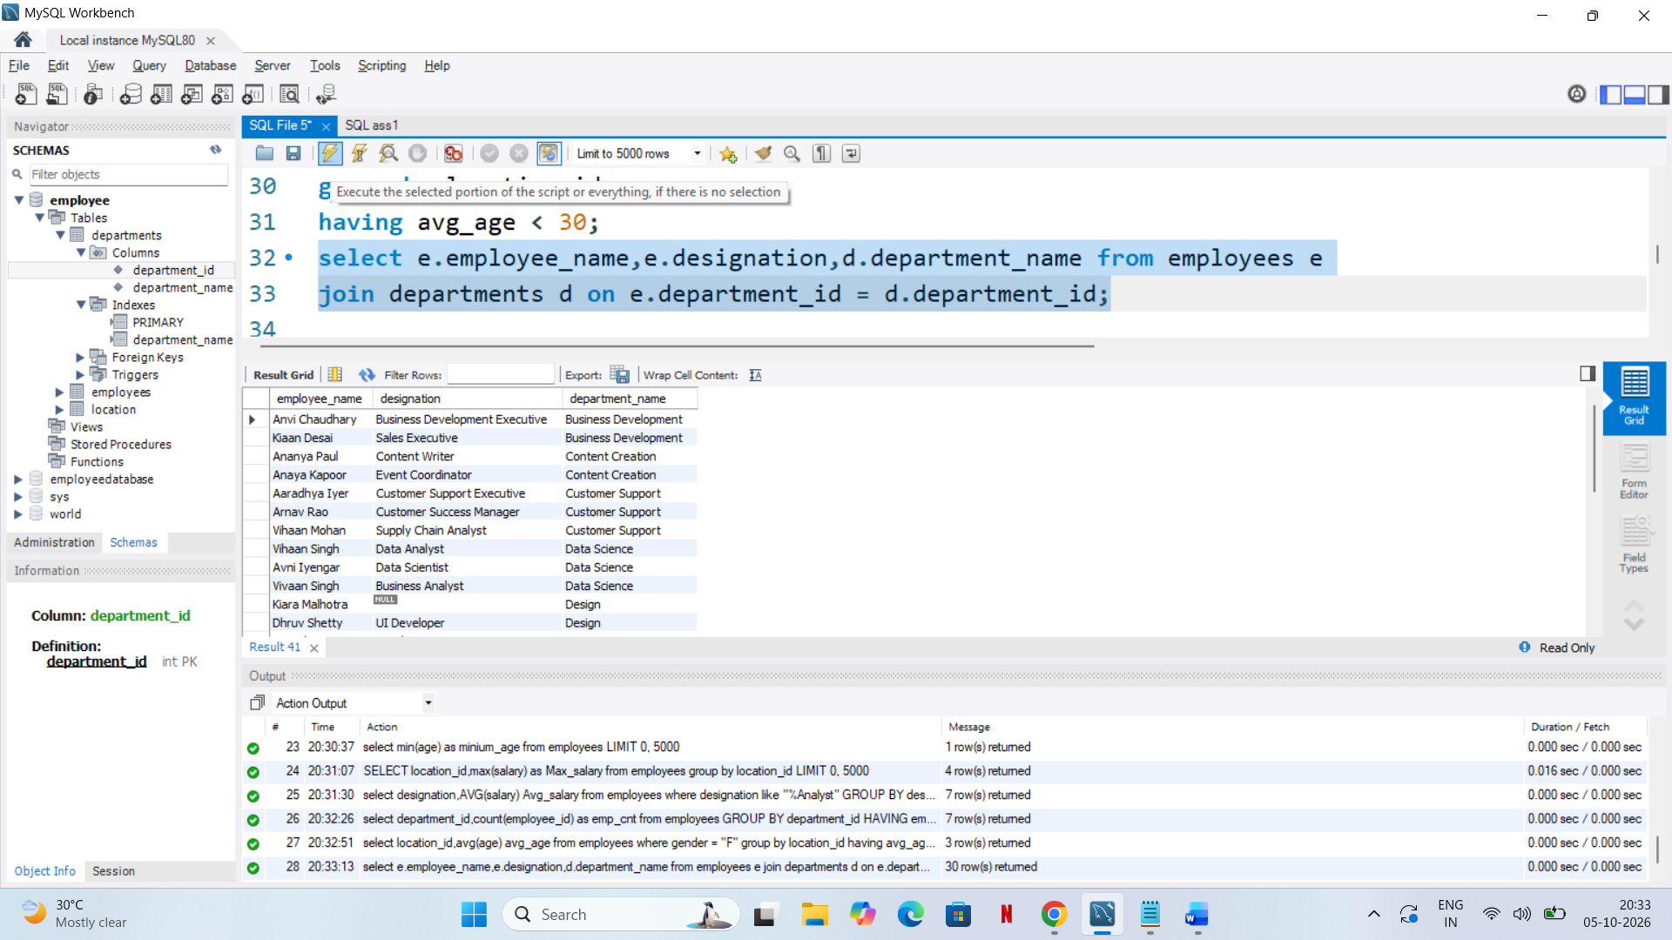
. List all departments along with the total number of employees in each department, including departments with no employees.
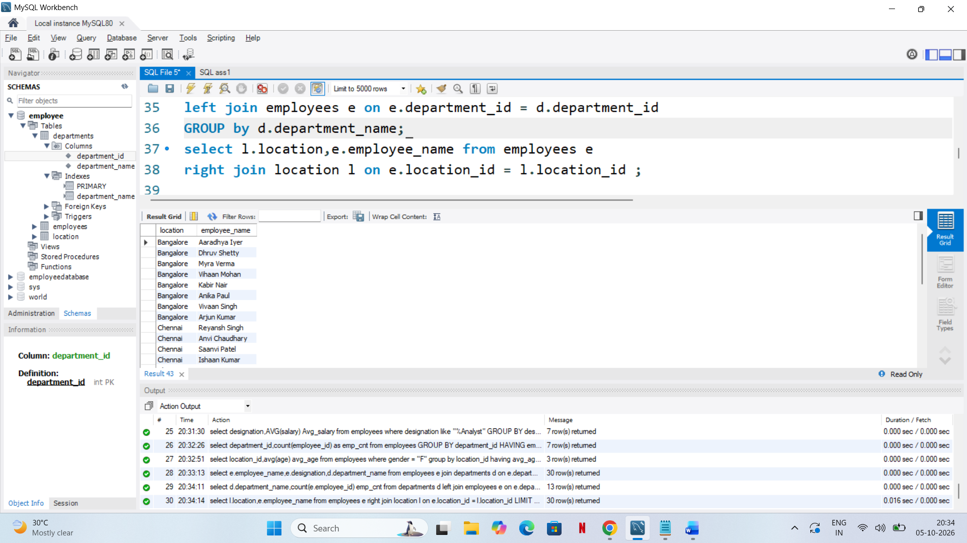
Display all locations along with the names of employees assigned to each location. If no employees are assigned to a location, display NULL for employee name.

